Airlines.dat

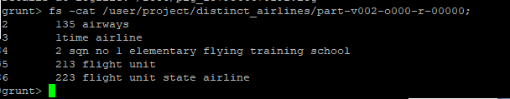

Find the number of airports in each country

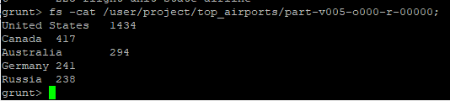

Routes.dat



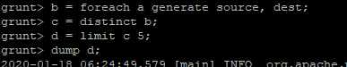

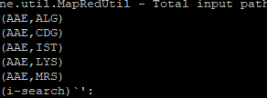

Airports vs routes:



